Brixhibition Kids Competition 2020

Punchbowl Primary School is excited to participate in the annual Brixhibition Lego competition. Students are encouraged to create and submit an original Lego model in our school competition.

- This year there will be 3 categories: Prep – Grade 2, Grade 3 – Grade 4, and Grade 5 – Grade 6.
- Models can be delivered to the Flying Start room before school on Monday 16th March and Tuesday 17th March.
- There will be a winner from each category and a ‘People’s Choice’ award.
- Viewing and voting will take place on Wednesday 18th March – Friday 20th March. Winners announced on Monday 23rd March and prizes awarded at the whole school assembly on Tuesday 31st March.

- Each overall winner is invited to display their winning Lego creations at Brixhibition Albert Hall, Tamar Street, Launceston on Sat 25th and Sun 26th April 2020.
- All Brixhibition Kids Comp winners displayed at Brixhibiton will be judged by Tasmanian Brick Enthusiasts Inc. members (approx. 30 judges)

Here are some photos of last year’s entries in our school competition
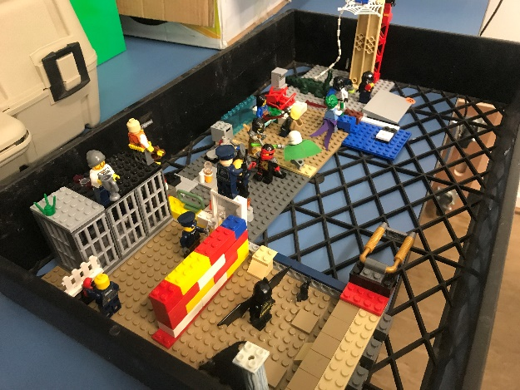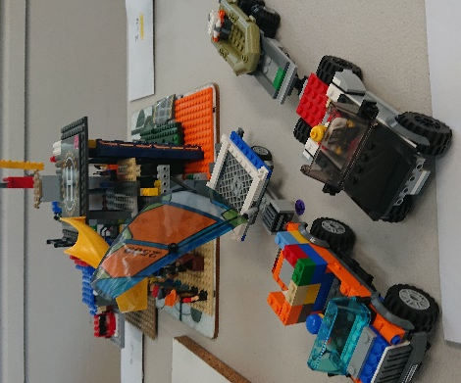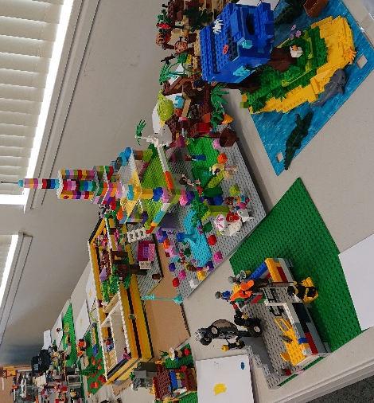

Brixhibition Grand Prize Winners to be awarded at Albert Hall

1st Place: Trophy and $300 Gamesworld Plus Voucher
2nd Place Trophy and $200 Gamesworld Plus Voucher
3rd Place Trophy and $100 Gamesworld Plus Voucher
4th Place Trophy and a Lego Set

Winners announced at 3pm, Sun 26th April 2020 at Brixhibition

Saturday 25th – Sunday 26th April 2020
9:30am – 4:00pm
Albert Hall Tamar Street, Launceston

Brixhibition Kids Competition

Conditions of Entry
- All participating students must be of Infant or Primary School age. (Prep – Grade 6)

- Students may only enter the Brixhibition Kids Comp once.
This can be either through a participating Primary School or a Community Centre (not both)

- Each Lego display to be no larger than 52cm x 52cm x 52cm, or no larger than four 32x32 lug Lego baseplates.

- Each Lego display must be an original or freelance design and not made from a Lego kit or any set of instructions.

- Some adult help is allowed, but the Lego design should mainly be the student’s own design.

Saturday 25th – Sunday 26th April 2020
9:30am – 4:00pm
Albert Hall Tamar Street, Launceston

